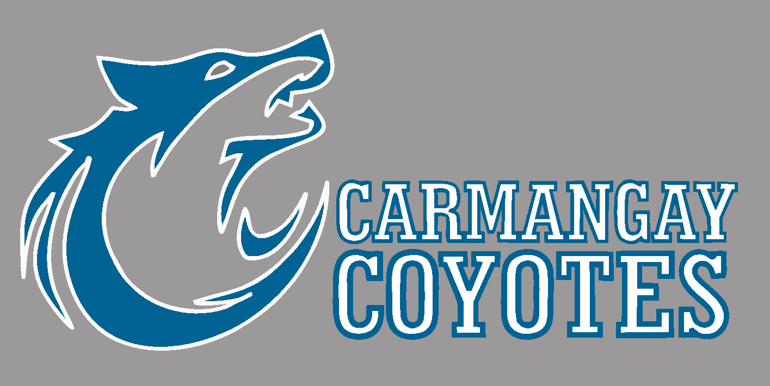
Carmangay School
November Newsletter

The school year is well under way. We have lots going on this November.

First, I would like to thank all families for allowing the students to help out the Carmangay community in their clean up. The students were so great and kind, and they worked hard cleaning yards.
On November 2, we will be hosting a Junior/Senior High Volleyball Tournament. We have invited Huntsville’s Junior & Senior High students and the grade 6 students in Barons to join us. The tournament will be running all day and the concession will be open.

Carmangay School Concession Price List – Volleyball - November 2, 2023
Hamburger $2.50
Cheeseburger $3.00
Hot Dog $1.50
Hot Dog with Cheese $2.00
Bag of Chips $1.00
Chocolate Bar $1.00
Bag of Candy $1.00
Frozen Rocket Pop $1.00
Ice Cream Sandwich $1.00
Hot Chocolate $1.00
Gatorade $2.00
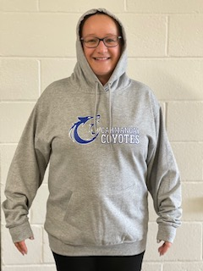
Bottle of Water $0.50

If your child is interested in buying a school hoodie or t-shirt, they will be on sale mid November. Order forms can be found on a table just outside the office.
This year we are selling them in 2 different colors: black and dark gray. Due date for order will be Nov. 23, 203.

November Hot Lunch will be on November 28th at our field trip. We will be ordering from Mama's Pizza so the cost will be a bit more. Order forms will be sent home soon.

November 16th, Students will go to the University of Lethbridge to take part in some fun classes, tour the university and cheer on our classmates that are competing in the Cardboard Boat Race.
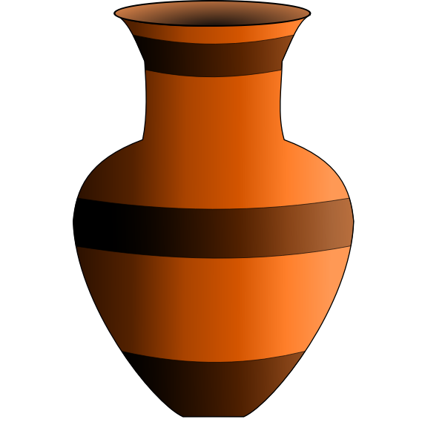
November 28th- Students will be going to County Central High School in Vulcan to create a Pottery item with their Art Teacher. We will be having our Pizza hot lunch at the school in Vulcan.

Picture retakes are Tuesday, November 21st. Just a reminder that this year that Life Touch will not be providing a free class picture. Families who order an individual photo package, will receive a class group photo at no additional cost. However, families who do not want to buy an individual photo package but would like a class group photo, will now have to purchase a class group photo for $9.99.

Parent Teacher Interview will be held November 23rd at Carmangay. Report Cards will be given out at this time. If you do not attend, report cards will be sent out the following school day.
Important Dates in November:

Nov. 2- Jr High Volleyball tournament
Nov. 10- Character Education Assembly and Fun Friday
Nov. 13- No School: Remembrance Day Holiday
Nov. 16- U of L Field Trip
Nov. 21- Picture retakes
Nov. 23 - Clothing Orders Due
Nov. 24- No School
Nov. 28th- Hot Lunch and Art Field Trip to Vulcan
November 2023
Mon |  | Tue | Wed | Thu |  | Fri
 |  |  | 1 | 2  Volleyball Tournament at Carmangay School |  | 3  NO SCHOOL
6 |  | 7 | 8 | 9 |  | 10  Character Education Assembly and Fun Friday
13  NO SCHOOL |  | 14 | 15 | 16  Field Trip to U of L  Cardboard Boat Races |  | 17
20 |  | 21  Picture Retake Day | 22 | 23 |  | 24  NO SCHOOL
27 |  | 28  Art Field Trip and Pizza Hot Lunch | 29 | 30

